*** Board of Governors ***
MARTHA’S VINEYARD HOSPITAL & AQUINNAH BOARD OF HEALTH & CHILMARK BOARD OF HEALTH
& EDGARTOWN BOARD OF HEALTH & OAK BLUFFS BOARD OF HEALTH
& TISBURY BOARD OF HEALTH & WEST TISBURY BOH
& WAMPANOAG TRIBAL HEALTH & DUKES COUNTY EMERGENCY MANAGEMENT


Dukes County
Medical Reserve Corps
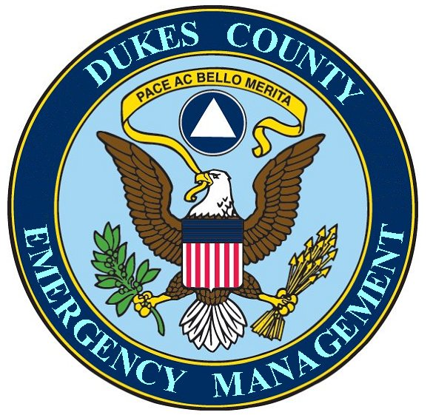

Handbook

Table of Contents

Welcome…………………………………………………………………….. 3

About this Handbook ………………………………………………………4

History of Citizen Corps/Medical Reserve Corps ……………………..5

Dukes County Medical Reserve Corps ………………………………….6

Background ………………………………………………………………….7

Results and Benefits Expected…………………………………………. 8

Organizational Chart ………………………………………………………9

General Information …………………………………………………10 – 11

Benefits, Training, Funding ……………………………………………...12

Recognition, Our Emblem, Website, Newsletter …………………….13

Liability ………………………………………………………………………14

Policies………………………………………………………………….15 - 17

Code of Conduct ………………………………………………………18 - 19

Volunteer Rights & Responsibilities…………………………………… 20

Forms…………………………………………………………………… 21 - 24

Notes 25

Welcome

Dear Medical Reserve Corps Volunteer,

On behalf of the Dukes County Medical Reserve Corps, the Board of Governors and the Dukes County Emergency Management Department, welcome and thank you for joining our volunteer team.

In Dukes County, we need over 700 volunteers to accomplish all our goals. Thank you so much for making the Medical Reserve Corps part of your volunteer activities.

This handbook was created to give you pertinent information that will maximize your volunteer experience. Please take the time to read through it and refer back to it as questions arise.

Always feel free to call the Dukes County Medical Reserve Corps for additional information or to pass along suggestions or comments. Our phone number is (508) 696-3811.

Once again, welcome to the Dukes County Medical Reserve Corps!

Sincerely,

(Name here)
Medical Reserve Corp Coordinator

About This Handbook

Your enrollment and orientation are important first steps to an exciting and complex organization, which offers a variety of opportunities to serve our community. The following pages describe the benefits to our volunteers, plus policies and procedures that provide a framework for the services we will deliver.

The information in this handbook is extensive, but not complete. Each position has policies and procedures specific to the function you will perform.

You will learn much of the information regarding your responsibilities on the job. If you have any questions along the way, contact us at (508) 696-3811.

Please take the time to read this handbook carefully. Then, keep it as a reference source to use when you have questions or concerns.

We wish you a rewarding experience as a Medical Reserve Corps volunteer.

History of Citizen Corps/Medical Reserve Corps

Uniting Communities - Preparing the Nation
In his 2002 State of the Union Message, President Bush called on all Americans to make a lifetime commitment of at least 4,000 hours—the equivalent of two years of their lives—to serve their communities, the nation and the world. President Bush announced the creation of USA Freedom Corps to help Americans answer his call to service and to foster a culture of service, citizenship and responsibility.

The Citizen Corps is the component of the USA Freedom Corps that creates opportunities for local individuals to volunteer to help their communities prepare for and respond to emergencies.

The Medical Reserve Corps is the component of the Citizen Corps that will bring together local health professionals and others with relevant health related skills to volunteer in their community. They will assist existing community emergency medical response systems, as well as provide a group of readily trained and available resources to help our community deal with pressing public health needs and improvements.

The Dukes County Medical Reserve Corps, founded by its Board of Governors, is proud to be the first on Martha’s Vineyard to set up an active Medical Reserve Corps. We were officially recognized by the Office of the Surgeon General on (DATE HERE).

Our goal is helping the Island of Martha’s Vineyard prevent, prepare for and respond to disasters, pressing public health needs and emergencies of all kinds.

Volunteers are key to making our community a safer place to live. We look forward to working with you in this important community effort.

Dukes County Medical Reserve Corps

Mission of the Dukes County Medical Reserve Corps

The mission of the Medical Reserve Corps (MRC) is to allow local volunteer medical and health professionals to contribute their skills and expertise throughout the year as well as during times of community need. Our Medical Reserve Corps unit is made up of medical, health, and non-medical support volunteers who can assist our community during emergencies, such as an earthquake, influenza epidemic, a chemical spill, or an act of terrorism.

Benefits to the Community
Major local emergencies can overwhelm the capability of first responders, especially during the first 12-72 hours. Having citizens who are prepared to take care of themselves, their families and others during times of crisis will allow first-responders to focus their efforts on the most critical, life threatening situations.

An organized, well trained Medical Reserve Corps unit means that volunteers can effectively respond to an emergency, are familiar with their community’s response plan, know what materials are available for their use, know who their partners in the response are, and know where their skills can be utilized to their best advantage and in a coordinated manner.

Background

The attacks on September 11, 2001 and Hurricane Katrina demonstrate how quickly a community can become overwhelmed and isolated during times of emergency.

In response to September 11th and Hurricane Katrina, the Medical Community and the Emergency Management Agencies identified a need for the development of a response structure to support volunteer efforts during emergencies. We decided to use the Medical Reserve Corps as a vehicle to orghaize vulunteer efforts for emergency preparedness.

The Island Boards of Health and the Marthaw’s Vineyarrd Hospital and the Dukes County Emergency Management Agency established the Duckes County Medical Reserve Corps by:

- Recruiting medical volunteers from existing lists created by the Island Boards of Health, the Martha’s Vineyard Hospital, the Dukes County Emergency managewment Agency and Massachusetts State Department of Health.
- Recruiting additional medical volunteers from various health disciplies to include, but not limited to, retirees, plus both active and retired military members.
- Recruiting non-medical volunteers to support admistrative and logistic functions of volunteer missions.
- Partnering with, hospitals, EMS and the public health community to develop medical command and control procedures and pre-positioned sites for medical volunteers to establish and manage when requested through Dukes County Emergency Management.
- Pre-registering all medical volunteers as Massachusetts State Emergency Workers.
- Developing an orientation, training and exercise program for volunteers

Results and Benefits Expected:


Recruitment for the Medical Reserve Corps (MRC) will be community based and volunteer managed. The recruitment process will not be limited to physicians and nurses. It will be inclusive of all medical professionals both licensed and those in administrative roleAlso non-medical volunteers will be recruited for support roles. The MRC will offer flexibility and allow volunteers to establish “volunteer time limits”.

Dukes County MRC will be designed to use local health professionals within the community and will accommodate the volunteer schedules.

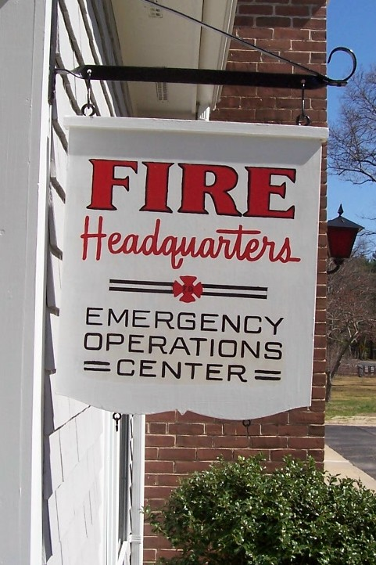
All emergency and disaster related functions of the MRC will be initiated through the Dukes County Medical Reserv Corps office. The MRC will enhance and improve the emergency medical response capacity in the community. The program will enhance the Island’s ability to respond to either a natural hazard or a terrorism event and be the designated volunteer corps utilized to manage: public health emergencies (flu pandemics), smallpox clinics, distribution of the strategic national pharmaceutical stockpile, plus the overflow treatment areas and field hospitals as needed in a terrorism event or disaster. With pre-planning, pre-identification of treatment sites, and pre-identified, certified, and trained volunteers, a safe, rapid, and effective service will be available in a major emergency or disaster.

The chart on the following page shows how the Medical Reserve Corps fits into the overall organizational structure.

DUKES COUNTY MEDICAL CORPS ORGANIZATIONAL CHART

(TO BE DETERMINED)

The Medical Reserve Corps will work under the direction of the (TO BE DETERMINED) during a disaster.

The Emergency Operations Center will activate the Medical Reserve Corps in times of disaster when necessary.

For non-emergency volunteer opportunities, the MRC will be activate by the (TO BE DETERMINED)

A briefing on the Chain of Command will be given prior to each volunteer opportunity.

General Information

Position Descriptions
When you join the Medical Reserve Corps, you should receive a volunteer position description. Your position description outlines the general and specific duties that you will be expected to perform. It should also outline the training required in order to carry out your assigned duties.

Volunteer Assignments
Most volunteer applications and interviews will go through the Dukes County Medical Reserve Corps.

The Dukes County Medical Reserve Corps will assign volunteers in advance of emergencies and public health activities.

The Medical Reserve Corps unit will work closely with the Island Health Agents, Island Emergency Managers, Martha’s Vineyard Hospital, Island Police Chiefs, Island Fire Chiefs, and Island EMS organizations and other Island emergency leaders because of their ongoing responsibilities and specific expertise
 | Birthdate:  05/14/52
 | Weight:  185 | Height:  5’10”
 | Color Hair:  Brown | Color Eyes:  Green
Social Security No.:
123-45-6789
Emergency Worker Assignment (WAC 118-04):
Medical Reserve Corps
Emergency Contact:

Spouse: Ms. Terry 360-425-1248
EMD-025 (7/00) (Back)

Identification

Dukes County Medical Reserve Corps will ensure that carefully controlled individual photo ID badges are prepared and issued to each volunteer.

Volunteer Safety

All volunteers will receive safety training that is appropriate to their function in the Medical Reserve Corps Unit. It is recommended that all volunteers have current immunizations, including tetanus, influenza, and Hepatitis B.

Maintaining Readiness
Regular training exercises are an essential element for ensuring readiness.

Being ready to respond in an emergency does not just happen—readiness requires planning, organization and practice.

The Dukes County Medical Reserve Corps will have regular meetings and drills to ensure maximum emergency preparedness.

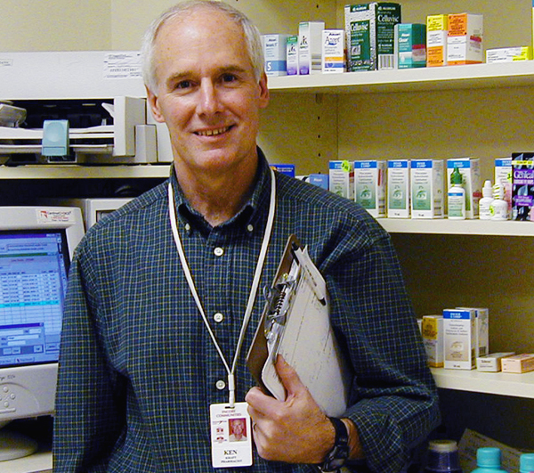
All Medical Reserve Corps volunteers must have appropriate education, training and experience. All members of the MRC unit do not need the same education and training, although there are some common elements. The MRC will be trained to:

  - Manage Emergency Dispensing Sites to support a mass vaccination strategy).
  - Manage the distribution of the Strategic National Pharmaceutical Stockpile.
  - Work in overflow treatment areas and field hospitals as needed.

Preparedness is each individual’s responsibility. Ensuring you are prepared at home and at work will allow you to be ready to respond when you are needed. Dukes County Medical Reserve Corps has free information that can help you prepare for all hazards. You may also check the website at http://www.dema.us/ for emergency preparedness information.

Benefits

The skills and services of each Medical Reserve Corps volunteer are critical to our success and effectiveness. Volunteer and paid staff are colleagues who form a team united by shared goals and values. Like any team, the contributions of each member are unique and crucial. By serving on the Medical Reserve Corps team, volunteer staff earns certain benefits. These benefits are outlined in the following pages.

Training
Medical Reserve Corps unit leaders should have a training checklist to ensure that volunteers who are registered can be documented on training they have had and/or need. All Medical Reserve Corps volunteer training must include:

- Medical Reserve Corps orientation
- NIMS 700; National Incident management System, An Introduction
- ICS 100; Introduction to Incident Command System
- Blood borne Pathogens
- CPR/First Aid

All registered volunteers are expected to participate in the Orientation course prior to starting as a volunteer. This program provides a broad overview of the various services and activities of the Medical Reserve Corps at the local & national level. Whenever possible, free training will be provided and Continuing Education Units (CEUs) will be offered.

Funding
Volunteer time is uncompensated. However, Dukes County Medical Reserve Corps is responsible for supplies and other support during a disaster, which may include:

- Education and training
- Protective equipment and clothing
- Supplies (gloves, syringes, splints, etc.)
- Food and shelter
- Communication equipment (cell phones, computers, etc.)

Recognition:
As a Medical Reserve Corps member, you will be invited to an annual appreciation ceremony hosted by the Dukes County Medical Reserve Corps.

Our Emblem:

The Medical Reserve Corps will be a recognized emblem that must be used in a standard form. There are guidelines that include color, placement, font and size. Correspondence requires certain placement of margins and addresses. Before distributing anything with our emblem, please check with your supervisor.

Web Site
The Dukes County Medical Reserve Corps is on the web! Go to our web site at www.dukescountymrc.org .
This site will keep you updated as to training schedules, events, etc. Your friends, colleagues, and family can even apply to be volunteers by downloading our online application forms.

Newsletter
All volunteers will be able to access a quarterly newsletter from the Dukes County Medical Reserve Corps website. If you do not have internet access, please let the volunteer program manager know and it will be sent to you. This newsletter will keep you up to date on what’s happening in the volunteer program. The newsletter will have statistics, volunteer profiles, new volunteer opportunities, and upcoming events.

Liability

Pursuant to various Massachusetts “Good Samaritan” statutes, including G.L. c. 112, §§12B and 12C, a physician, physician assistant, registered nurse or licensed practical nurse who renders emergency care/treatment or who administers immunizations, or any other protective program under a public health program, in good faith, as a volunteer and without fee and other than in the course of his/her practice, cannot be held liable in a suit for damages as a result of his/her acts or omissions.

If I am not immune from liability pursuant to any “Good Samaritan” statute, I agree to indemnify, defend and hold harmless the Town of Duxbury, its agencies, departments, officers, employees, agents and assigns, from all loss, costs, damage, injury, liability, claims and causes of action whatsoever, arising out of or related to any act, error or omission on my part while participating in this volunteer program.

The Volunteer Protection Act
(“VPA”)(codified at 42 U.S.C. § 14501 et. seq.) Provides qualified immunity from liability for volunteers and, subject to exceptions, preempts inconsistent state laws on the subject, except for those that provide protections that are stronger than those contained in the VPA.

The VPA defines a volunteer as “an individual performing services for a nonprofit organization or a governmental entity which does not receive compensation" (other than reasonable reimbursement or allowance for expenses actually incurred); or any other thing of value in lieu of compensation, in excess of $500 per year....” 42 U.S.C. § 14506(6).
Under the VPA, a volunteer of a nonprofit organization or governmental entity is immune from liability for harm caused by an act or omission of the volunteer on behalf of the organization or entity if: (1) the act or omission was within the scope of the volunteer’s responsibilities in the organization or entity; (2) if required, the volunteer was properly licensed, certified, or authorized by the appropriate state authorities for the activities or practice giving rise to the claim; (3) the harm was not caused by “willful or criminal misconduct, gross negligence, reckless misconduct, or a conscious, flagrant indifference to the rights or safety of the individual harmed by the volunteer,” and (4) the harm was not caused by the volunteer’s operation of a motor vehicle, vessel, aircraft, or other vehicle for which the state requires the operator to possess a license or maintain insurance. 42 U.S.C. § 14503(a).

NON-MEDICAL LIABILITY Medical Reserve Corps unit volunteers may be subject to liability for acts not related to their professional activities, such as negligent motor vehicle operation during the course of responding to an emergency.
Policies

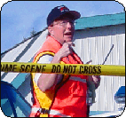
Harassment-Free Environment Policy
The Dukes County Medical Reserve Corps (MRC) is committed to providing a harassment/discrimination free work environment in which all individuals are treated with respect and dignity. Each individual has the right to work in a professional atmosphere that promotes equal opportunities and prohibits discriminatory practices, including harassment. It is the policy of the MRC that harassment based on race, color, religion, age, gender, sexual orientation, national origin, marital status, disability, veteran status or any other basis is strictly prohibited.

Any harassment, whether verbal or physical, is unacceptable and will not be tolerated. It is the intent that all MRC volunteers will work in an environment free from discrimination and/or harassment by another employee, supervisor or another volunteer for any reason. Discriminatory conduct in any form undermines morale and interferes with productivity.

The Dukes County Medical Reserve Corps is committed to eradicating all discrimination in the workplace and specifically condemns sexual harassment of town employees and volunteers by other town employees or volunteers.

If you feel you may have been the subject of discrimination or harassment, you should report it immediately. Any reports of discrimination or harassment will be examined impartially and resolved promptly.

The MRC undertakes its responsibility to prevent workplace harassment seriously. To achieve this goal, the MRC presents all new volunteers with this policy during orientation and is included in the volunteer manual.

Safety
Providing a clean, safe and healthful work environment is a goal of the Dukes County Medical Reserve Corps. No job is considered so important or urgent that volunteers cannot take time to perform their job safely.

During your job site orientation, your supervisor will discuss all the applicable safety and health rules with you. If you are unclear about any safety policies and procedures, ask your supervisor or volunteer manager.

As a MRC volunteer, you have a responsibility for your own safety and health. This includes using all required safety devices. You must also notify your supervisor of any physical conditions such as drowsiness due to medication, illness or emotional strain, which may affect your performance and safety.

You are expected to immediately report all work-related accidents, injuries, illnesses and near misses to your supervisor or volunteer manager.

Electronic Communications Policy
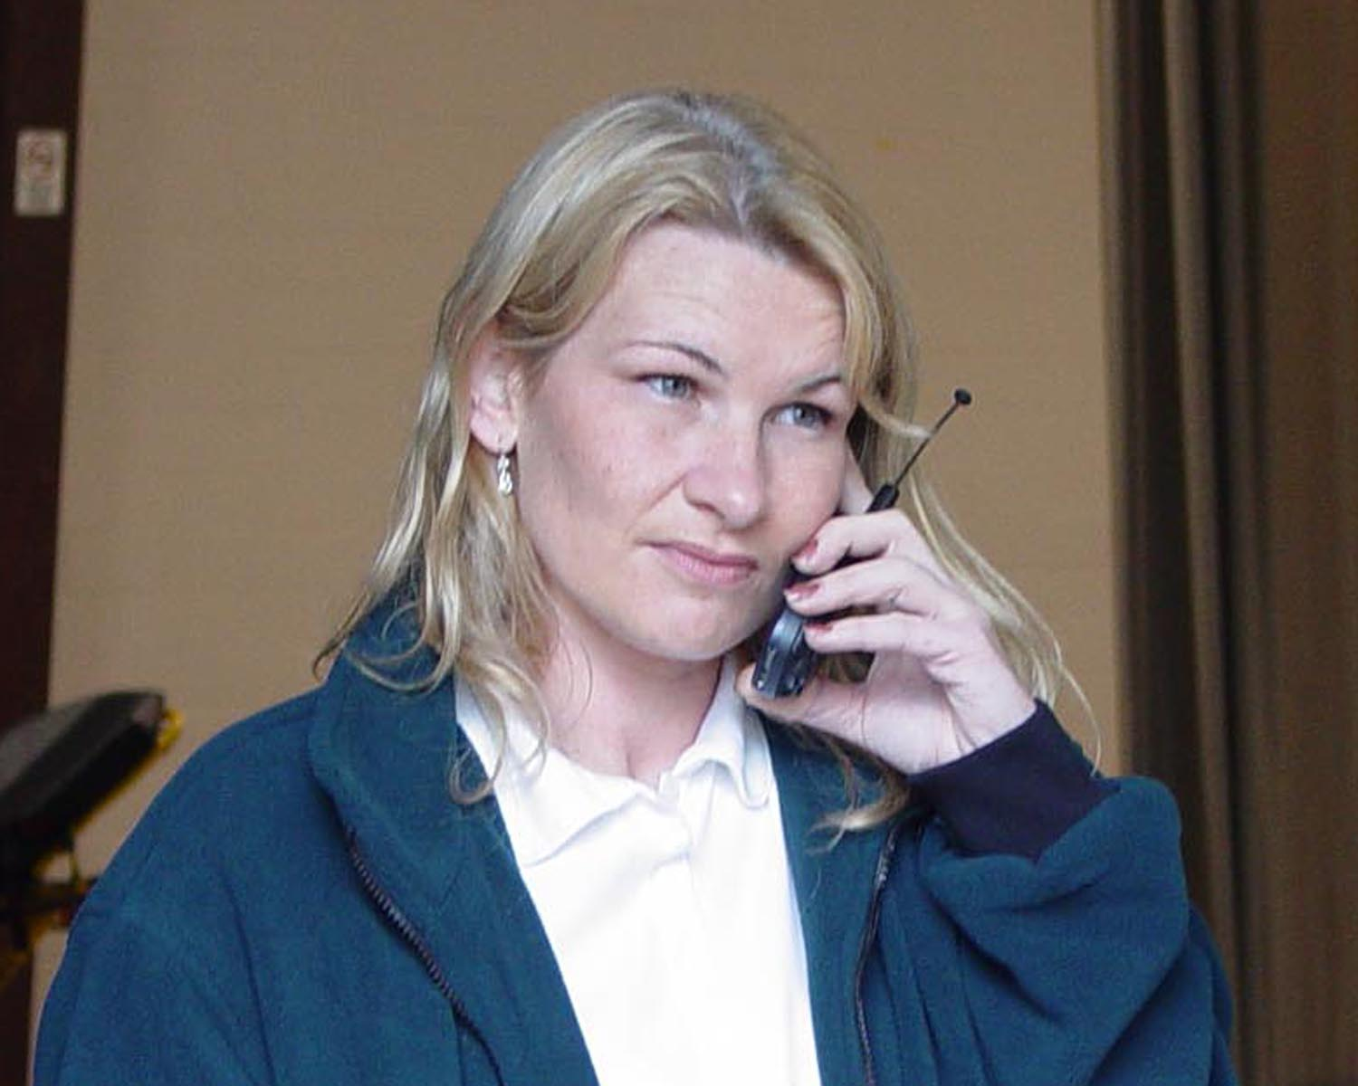
Dukes County electronic communication systems, including telephones, e-mail, voice mail, faxes and Internet, are available to conduct County business in a timely manner. All communications are to be professional and appropriate and users are prohibited from using electronic communications for the solicitations of funds, political messages, harassing messages or personal use. Furthermore, all electronic data is the property of the Dukes County and may be considered public records.

Drug Free Workplace
The Dukes County Medical Reserve Corps (MRC) is dedicated to a safe, healthy and drug-free work environment. All MRC volunteers are expected to report to work free from drug and/or alcohol impairment and to remain at work in a condition that enables them to perform their job duties in a safe, efficient, legal and professional manner. Dukes County Medical Reserve Corps encourages volunteers who may have an alcohol and/or drug problem to voluntarily seek evaluation and treatment that will lead to successful rehabilitation. Volunteers must abide by the provisions of this policy as a condition of volunteer service.

Violence-Free Work Environment Policy
The Dukes County Medical Reserve Corps (MRC) is committed to our volunteer’s safety and health. This policy has been developed to help ensure a safe workplace and to reduce the risk of violence.

The MRC does not tolerate any type of acts or threats of violence committed by or against a volunteer, and therefore prohibits workplace violence and the possession of weapons by volunteers on the job and at the worksite.

In order to ensure a safe working environment, the Dukes County Medical Reserve Corps prohibits all persons from carrying a handgun, firearm, or weapon of any kind on assignments, regardless of whether the person is licensed to carry the weapon or not. This policy applies to all volunteers, clients, customers and visitors. All volunteers are also prohibited from carrying or using a weapon while in the course and scope of performing their job, whether they are on our property at the time or not. This policy also prohibits weapons at any Medical Reserve Corps sponsored function, such as training missions, parties or any other events.

The only exceptions to this policy are police officers, private security guards, or military personnel employed by federal, state or local government, who are engaged in official duties.

If you feel threatened, you should retreat and request intervention from a supervisor or other available management staff. If fear of violence is imminent, immediately retreat and contact 911.
Code of Conduct

Introduction
In an effort to maintain the high standard of conduct expected and deserved by the American public and to enable the organization to continue to offer services required by those in need, the MRC operates under the following Code of Conduct, applicable to all volunteers.

Code of Conduct
No volunteer shall:

- Authorize the use of or use for the benefit or advantage of any person, the name, emblem, endorsement, services, or property of the Medical Reserve Corps.

- Accept or seek on behalf of himself or any other person, any financial advantage or gain of other than nominal value which may be offered as a result of the volunteer’s affiliation with the Medical Reserve Corps.

- Publicly utilize any Medical Reserve Corps affiliation in connection with the promotion of partisan politics, religious matters, or positions on any issue not in conformity with the official positions of the Citizen Corps.

- Disclose any confidential Medical Reserve Corps (MRC) information that is available solely as a result of the volunteer’s affiliation with the MRC to any person not authorized to receive such information, or use to the disadvantage of the Medical Reserve Corps any such confidential information, without the express authorization of the MRC.

- Knowingly take any action or make any statement intended to influence the conduct of the Medical Reserve Corps in such a way as to confer any financial benefit on any person, corporation, or entity in which the individual has a significant interest or affiliation.

- Operate or act in any manner that is contrary to the best interests of the Medical Reserve Corps.

- In the event that the volunteer’s obligation to operate in the best interests of the Medical Reserve Corps conflicts with the interests of any organization in which the individual has a financial interest or an affiliation, the individual shall disclose such conflict to the Medical Reserve Corps volunteer manager upon becoming aware of it, shall absent himself or herself from the room during deliberations on the matter, and shall refrain from participating in any decisions or voting in connection with the matter.

Performance
Volunteers are expected to comply with the policies, procedures, and standards of the Corps as explained at the beginning of their assignment, at the volunteer orientation and in the volunteer handbook.

If a supervisor is dissatisfied with a volunteer’s performance, the first course of action is to communicate that concern to the volunteer. If they are unable to reach an understanding, the director will resolve the matter. In most cases, a volunteer will be given sufficient time to respond affirmatively or request reassignment to a more suitable placement. In some cases however, immediate action may be required, depending upon the severity of the issue.

Commitment to Diversity
The Dukes County Medical Reserve Corps is committed to being a diverse organization. It seeks to recognize value and incorporate diversity in its services, policies and operations, service recipients, and paid and volunteer workforce. Diversity includes differences such as age, belief, citizenship, culture, economic level, ethnicity, gender, language, national origin, and philosophy of life, physical ability, physical appearance, race, religion, and sexual orientation.

Volunteer Rights & Responsibilities

Volunteer Rights
As a volunteer with the Dukes County Medical Reserve Corps, you enjoy certain rights that should be recognized by your supervisor and staff at your agency.

1. An interview and orientation
2. You should be given assignments that utilize and develop your skills.
3. Adequate information and training to carry out your assignments.
4. Clear and specific directions.
5. You should receive recognition and appreciation for your contribution.
6. You should have the opportunity to offer feedback and ask questions.
7. Expect regular feedback on your work.
8. Have adequate space, equipment and supplies to perform your job.
9. You have the right to know as much about the organization as possible.
10. Be respected in your workplace.

Volunteer Responsibilities
Volunteers expect, and enjoy, certain rights when they donate their time. Volunteers, however, also have specific responsibilities to the Medical Reserve Corps. As a volunteer you are free to set your own work schedule, but you must be prepared to fulfill the commitments you make.

1. You must be dependable, reliable, and businesslike, and abide by the policies of the Corps
2. Dress appropriately for the setting and the task at hand
3. Carry out duties in a safe, responsible way
4. Maintain the confidentiality of information revealed to you regarding clients and coworkers
5. Keep track of the hours you work on the form provided
6. You must be non-discriminatory in serving all people regardless of race, gender, age, religion, sexual orientation, or disability
7. Work within the guidelines of your job description and accept supervision
8. Offer feedback and suggestions
9. Be prepared for any regularly scheduled meetings
10. You must represent the Medical Reserve Corps appropriately in the community

Forms

 | Department of Emergency Management
 |  | Volunteer Time Log
Name/Title____________________________ |  |  |  | Month___________
Date | Time In | Time Out | Total Hours | Mileage | Activity
Total Hours___________ |  | Total Mileage__________ |  | Signature__________________________
Logged/Verified_______________________________ |  |  |  |  | Date____________

Confidentiality

Due to the nature of services of the Medical Reserve Corps (MRC), you may process information that is confidential and not public record. For that reason, you are asked to sign a confidentiality statement indicating that you will keep information to which you have access confidential and not discuss it with anyone other than the staff person with whom you are working.

CONFIDENTIALITY PLEDGE

I,________________________________certify that I have read the statement below and agree to comply with the terms.

I realize that, as an Emergency Worker with Dukes County Medical Reserve Corps, I may acquire knowledge of confidential information from files, case records, missions, conversations, etc. I agree that such information is not to be discussed or revealed to anyone not authorized to have the information.

Date______________

Signature__________________________________

Photography Consent

Dukes County Medical Reserve Corps frequently takes photographs of volunteers in action during trainings, exercises, and actual events. In addition, each volunteer is photographed for identification purposes. Photographs may be used on the website, in newsletters, and other publications.

Please sign the appropriate line below:

I give Dukes County Medical Reserve Corps permission to use my photo as stated above.

Signature Date

I do not give Dukes County Medical Reserve Corps permission to use my photo as stated above.

Signature Date

Receipt of Handbook

I have received a copy of the Dukes County Medical Reserve Corps Handbook. I have read and understood the policies and information in it and agree to abide by these policies during my volunteer term.

_____________________________ __________
Signature Date

Notes

